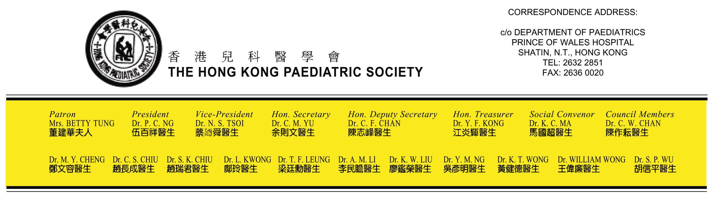
29 June 2005

To Chairman and Members of Rehabilitation Programme Plan Review Working Group

Dear sir,

On behalf of the council of the Hong Kong Paediatric Society, we would like to express our sincere gratitude to you for your immense achievement over the years in improving the services for the disable persons in Hong Kong. Your effort in the formulation and implementation of rehabilitation policy has attended to the special needs of people with various disabilities and indeed greatly improved the standard of care and attention to these people.

The Hong Kong Paediatric Society is a professional association with special interest in the promotion of child health. We are aware of the recent debate in your working group whether Attention Deficit Hyperactivity Disorder (ADHD) should be classified as one of disability categories. We would like to take this opportunity to express our concern for the health and well being of children with this particular disabling condition.

ADHD is a common neurodevelopmental disability syndrome firstly described in 1902. ADHD affect about 3 - 10 % of children and 1 – 6 % adult. The onset of ADHD is usually from early childhood presenting with persistent behavioural disturbance, impaired social and academic performance resulting in emotional distress for both patient and their family. Recent studies showed that 60-80 % of affected children continue to show significant symptoms of the disorder into adulthood. A high proportion of ADHD have other co-morbidity conditions including conduct disorder, depression, learning difficulty and antisocial behaviour. Even though there is no specific laboratory test for ADHD, there are well-defined diagnostic criteria for clinical evaluation. Rating scales and psychological testing instruments have been developed and validated for the assessment of the condition. Mounting evidences have been presented to illustrate the neurobiological deficit in the pathophysiology of ADHD. Neurophysiological studies implicated dopamine and norepinephrine neurotransimitter systems in frontostriatal circuitry in the pathophysiology of the disorder. Furthermore, studies of twins between the ages of 4 and 16 years indicated that approximately 75% of the etiologic contribution to ADHD is genetic, much higher than that of depression (39%), general anxiety (32%) or asthma (39%). The most widely confirmed gene association is the 7-repeat (7R) allele of the D4 dopamine receptor gene (DRD4*7) found in about 50 – 60 % of the population with ADHD. A recent report from a group local researchers suggested that the 2-repeat (2R) allele instead of the (7R) is significantly increased in prevalence in Chinese ADHD. Treatment of ADHD requires the development of child specific treatment plan focused on the target outcomes. Stimulants had been employed since 1930’s and many studies have documented its efficacy. Behavioural therapy, other psycho-social treatment, neurofeedback or alternative treatments in combination were advocated for these children with various degree of success.

From the above account, it is obvious that ADHD continues to be a serious child health problem affecting a significant portion of our children. Early diagnosis and appropriate treatment may ameliorate the suffering and some of the long term complications associated with this condition. We are grateful that your working group has considered to address the health care and rehabilitation program needs of these children with ADHD. The Hong Kong Paediatric Society support to include ADHD into the disability category and we would be most ready to offer our professional support in whichever way deem appropriate.

Thank you very much for your attention.

With regards

Dr Yu Chak Man
Hon Secretary
The Hong Kong Paediatric Society

