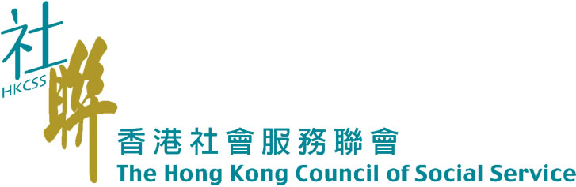

Enrollment Form
To: Service Development (C&Y) Fax: 2866 0863

Organization/School: _____________________________

Registration for Youth Creativity Development Sharing Session (Oct.23, 2010)
(Youth is free of charge)
Name (Youth) | Name(Social Workers, Teachers and Interested Parties)
- ____________________________  - ____________________________  - ____________________________  - ____________________________  - ____________________________  - ____________________________ | - ____________________________  - ____________________________  - ____________________________  - ____________________________

*Please to indentify which guest you want to share with (can choose more than one):
 Film Industry: Director Lee Lik Chee, Film Director and Screenplay Writers
Design Industry: Dr Raymond Choy, Founder and President of Toy2r (Holdings) Company Limited
IT Industry: Mr. Charles Mok, Chairman, Internet Society Hong Kong
Media Industry: Ms. Hyper BB, SKYHIGH Creative Partners
Music Industry: Mr. Clayton Cheung, Founder of the Big Bang Music Ltd.
Cultural Sector: Ms. Ada Wong, JP, Chief Executive of the H.K. Institute of Contemporary Culture
Academia: Ms May Fung, Acting Principle of the HKICC Lee Shau Kee School of Creativity
Social Welfare Sector: Mr. Gary Tang, Supervisor the Hong Kong Federation of Youth Groups

*Which topic(s) would you like to discuss with the guest?
1.________________________________________________________________________
2.________________________________________________________________________
3.________________________________________________________________________
4.________________________________________________________________________

Enrollment Form
To: Service Development (C&Y) Fax: 2866 0863
Organization/School: _____________________________
Registration for 1st Visit (Oct.30, 2010)
Name (Youth) | Name(Social Workers, Teachers and Interested Parties)
1.____________________________  2.____________________________ | - ____________________________  - ____________________________  - ____________________________  - ____________________________

Registration for 2nd Visit (Nov 5, 2010)
Name (Youth) | Name(Social Workers, Teachers and Interested Parties)
1.____________________________  2.____________________________ | 1.____________________________  2.____________________________  3.____________________________  4.____________________________

Registration for 3rd Visit (Nov.13, 2010)
(Youth from CSSA families is free of charge, please identify the first 4 no. of the I.D. number)
Name (Youth) | Name(Social Workers, Teachers and Interested Parties)
1.____________________________  2.____________________________ | 1.____________________________  2.____________________________  3.____________________________  4.____________________________

Enrollment Form
Enrollment Fee for:
Sharing session on October 23, 2010 : $60 (Youth is free of charge)
3rd Visit on November 13, 2010 : $20 (Youth from CSSA families is free of charge)

Total Amount $
*Please make crossed cheque payable to The Hong Kong Council of Social Service and post to:
Service Development (Children & Youth), Hong Kong Council of Social Service, Room 1213, 12/F Duke of Windsor Social Service Building, 15 Hennessy Road, Wanchai, Hong Kong .
Please fill the mailing address for receipt posting： | Contact Person：  Title： _  Tel. no.： ____  Email ： ____  Fax no.：
Organziation/School：____________________
Name：_________________________________
Address：_______________________________________
_______________________________________
_______________________________________

*If you would like to receive more information about the youth creativity training information, please leave contact information to us: (Please the appropriate item)*
□Youth □Social Worker □Teacher □Other：____________________________________

Name：______________________ Email：___________________________________________

☺ Thank you for your participation ☺

