September 22, 2004


Professor Peter TOWNSEND
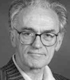
University qualifications and teaching
Peter Townsend is Centennial Professor of International Social Policy (and was in 2002 Acting Director of the Centre for the Study of Human Rights) at the London School of Economics. He is also Emeritus Professor of Social Policy in the University of Bristol. He has Honorary Doctorates from the University of Essex, 1991, the University of Teesside, 1994, the Open University, 1995, the University of Edinburgh, 1996, the University of Lincolnshire and Humberside, 1997, the University of York 2000, and the University of Stirling 2002. In 1999 he was elected a founder Academician of the new Academy of Learned Societies for the Social Sciences (AcSS). In 2004 he was elected Senior Fellow of the British Academy (FBA).

After early years as Research Secretary and Research Officer of Political and Economic Planning and the Institute of Community Studies, 1952-57, he was Research Fellow and lecturer at the London School of Economics, 1957-1963, and then appointed Professor of Sociology at the University of Essex upon its foundation in 1963. He held this post for 18 years. In 1982 he moved to the University of Bristol to become Head of the Department of Social Policy and Social Planning for 11 years. In 1991-92 he was Michael Harrington Distinguished Visiting Professor of Social Science, Queens College, City University of New York. From 1993 he continued to teach an MSc programme at Bristol. In 1998 he re-joined LSE, teaching on several of the graduate courses in development and human rights.

Current research
Since 1990 his publications include six books based on new research: The International Analysis of Poverty (1993), A Poor Future (1996), Poverty and Social Exclusion in Britain (with other authors, 2000), Breadline Europe: The Measurement of Poverty (co-editor), 2001), World Poverty: New Policies to Defeat an Old Enemy (co-editor), 2002. Child Poverty in the Developing World (with other authors, 2003).

Primary interests: poverty, human rights, inequalities in health, pensions.

International Agencies
During 1960-1990 he served in various capacities for the UNESCO, WHO and ILO. He was consultant to the UN 1993-95 during the preparations for, and at, the World Summit for Social Development at Copenhagen in March 1995; and was a member of a UNDP Management Development Programme mission to the Republic of Georgia in 1994. Consultant/expert to the EU (1998); UNRISD (1999); the Royal Danish Ministry for Foreign Affairs (the Copenhagen Seminars 1997-2001); UN Division for Social Policy (2001). He is currently a member of a UNICEF research team [2000-]. In the 1990s and early 2000s he undertook cross-national research and administrative assignments for the European Union, the International Labour Office the United States Institutes of Health, and the Public Health Department of Harvard University.

Principal Current Non-Academic Activities

Child Poverty Action Group: Among founding members 1965, Chairman 1969-1989, Life President 1989-.

Disability Alliance: Founder (with Alan Walker) 1973-74; Chair 1974-99, President 1999- .

National Assembly for Wales: Chair of the National Advisory Group 2000-2, and then Chair of the Standing Committee 2002-, on the Allocation of NHS Resources

Fabian Society: Member 1947-; Elected Member of Executive Committee 1958-89; Chairman 1965-66; Chairman of Home Policy, Social Policy and Research Committees for 15 years; Vice President 1989- .

Rt. Hon Jean CORSTON MP

Member for Bristol East since 9 April 1992 general election

Parliamentary Career
Parliamentary Private Secretary to David Blunkett as Secretary of State for Education and Employment 1997-2000

Current posts
Member British-Irish Inter-Parliamentary Body;
Member Executive Committee, Commonwealth Parliamentary Association (CPA) UK Branch 1999-;
Co-Chair All-Party Alternative and Complementary Medicine Group 1999-;
Member Select Committee on Liaison 2001-;
Chair of the Parliamentary Labour Party 2001-,
Chair of the Joint Select Committee on Human Rights 2001-

Backbench Committees
Co-chair, Parliamentary Labour Party Women's Group 1992-97;
Chair, PLP Children and Family Group 1995-97;
Member, Labour Party Departmental Committees for:
Agriculture, Fisheries and Food 1997-2001,
Education and Employment 1997-2001,
Home Affairs 1997-2001;
Chair, PLP Civil Liberties Group 1997-
All Party Groups: Office Holders
Co-Chair, Alternative and Complementary Medicine Group 1999-

International Bodies
Associate Member, British-Irish Inter-Parliamentary Body 1998-2001, Member 2001-02;
Member, Executive Committee, Commonwealth Parliamentary Association (CPA) UK Branch 1999-;
Chair, Commonwealth Women Parliamentarians 2000

Party Groups
Parliamentary Labour Party:
Deputy Chair 1997-98, 1999-2000,
Chair 2001-

Special interests
Equal Opportunities, Disability, Human Rights, Complementary Medicine

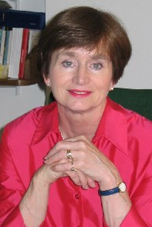

The first woman to chair the Parliamentary Labour Party, Jean Corston is a campaigning feminist and a standard-bearer for the left, though with links to the Government through her previous post as Parliamentary Private Secretary to David Blunkett at the Department for Education. She now chairs the Joint Committee on Human Rights.

Dr. YAP Mui Teng
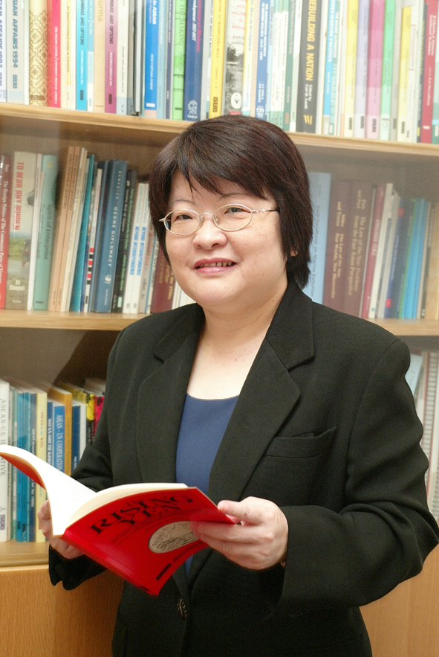
Yap Mui Teng Yap is a Senior Research Fellow at the Institute of Policy Studies (IPS), Singapore, where she works on demographic and family issues. She holds a Bachelor of Social Sciences (Honours in Sociology) degree from the University of Singapore, and an MA (specialising in Population Studies) and a PhD degree in Sociology from the University of Hawaii. Prior to joining the IPS, she had worked at the Population Planning Unit, Ministry of Health.

Dr Yap has researched and written on various areas of public policy in Singapore including marriage and procreation, migration, ageing, and poverty. Her recent publications include: “Poverty Monitoring and Alleviation in Singapore,” in Poverty Monitoring and Alleviation in East Asia, edited by Kwong-Leung Tang and Chack-Kie Wong (New York: Nova Science Publishers); “Fertility and Population Policy: the Singapore Experience”, Japanese Journal of Population, Supplement to Volume 1, Part II (a web journal); and Singapore Perspectives 2003 (an edited volume of conference proceedings).

Dr Yap is currently a member of the Interministerial Committee on the Ageing Population, a Resource Person for the Southwest Community Development Council, and a Board member of the Singapore Action Group of Elders (SAGE).

